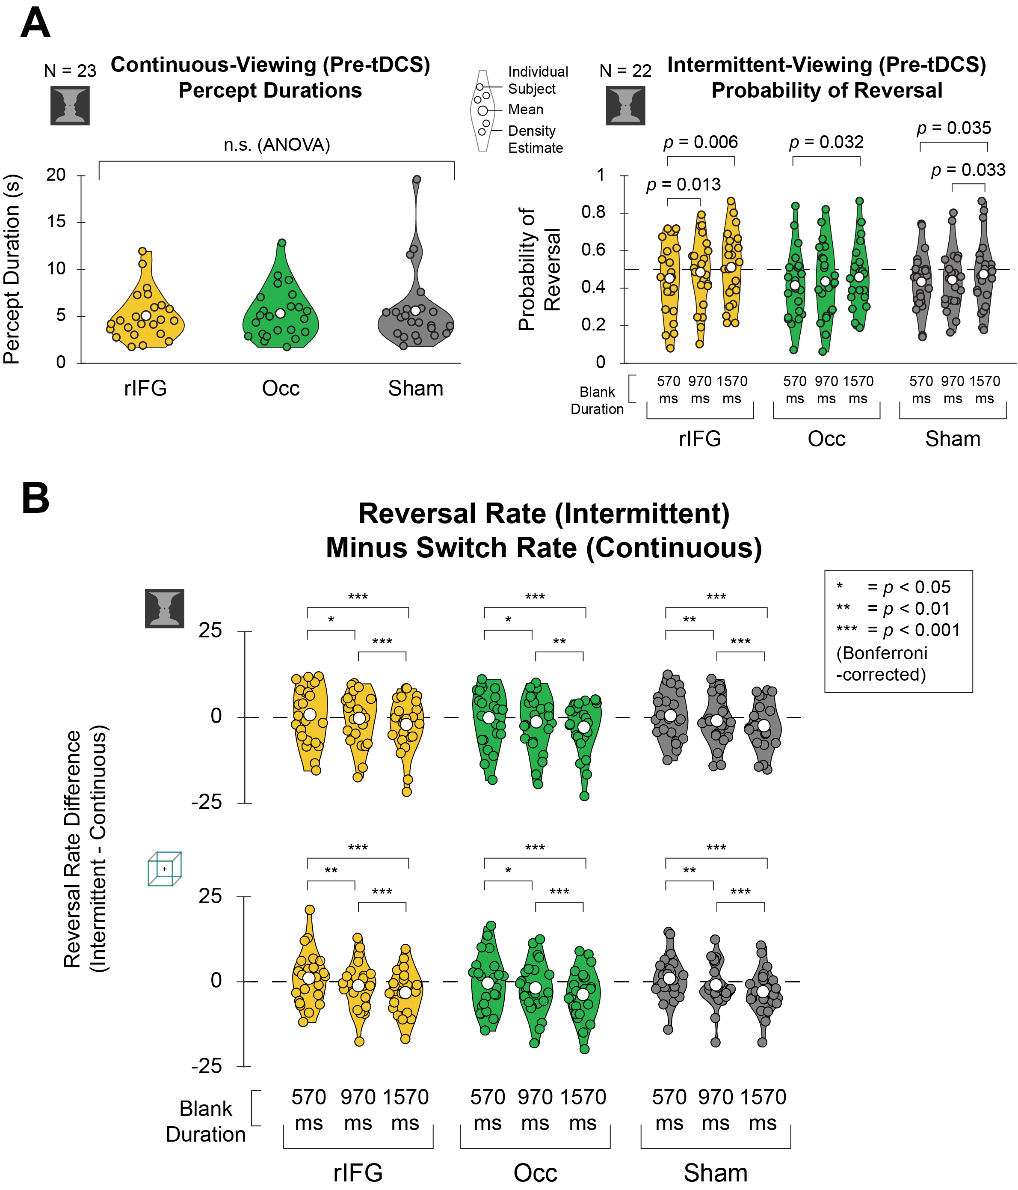
Fig. S1. Pre-tDCS data (for face-vase trials) and reversal rates compared to continuous-viewing (for both images). (A) Behavioral data across subjects for face-vase trials in the pre-tDCS task. Dotted line for intermittent-viewing data (Right) indicates 0.5 probability of reversal. (B) Raw reversal rates (i.e. number of switches/60 sec in intermittent-viewing condition) after subtracting switch rate in the continuous-viewing condition (calculated separately for each subject).
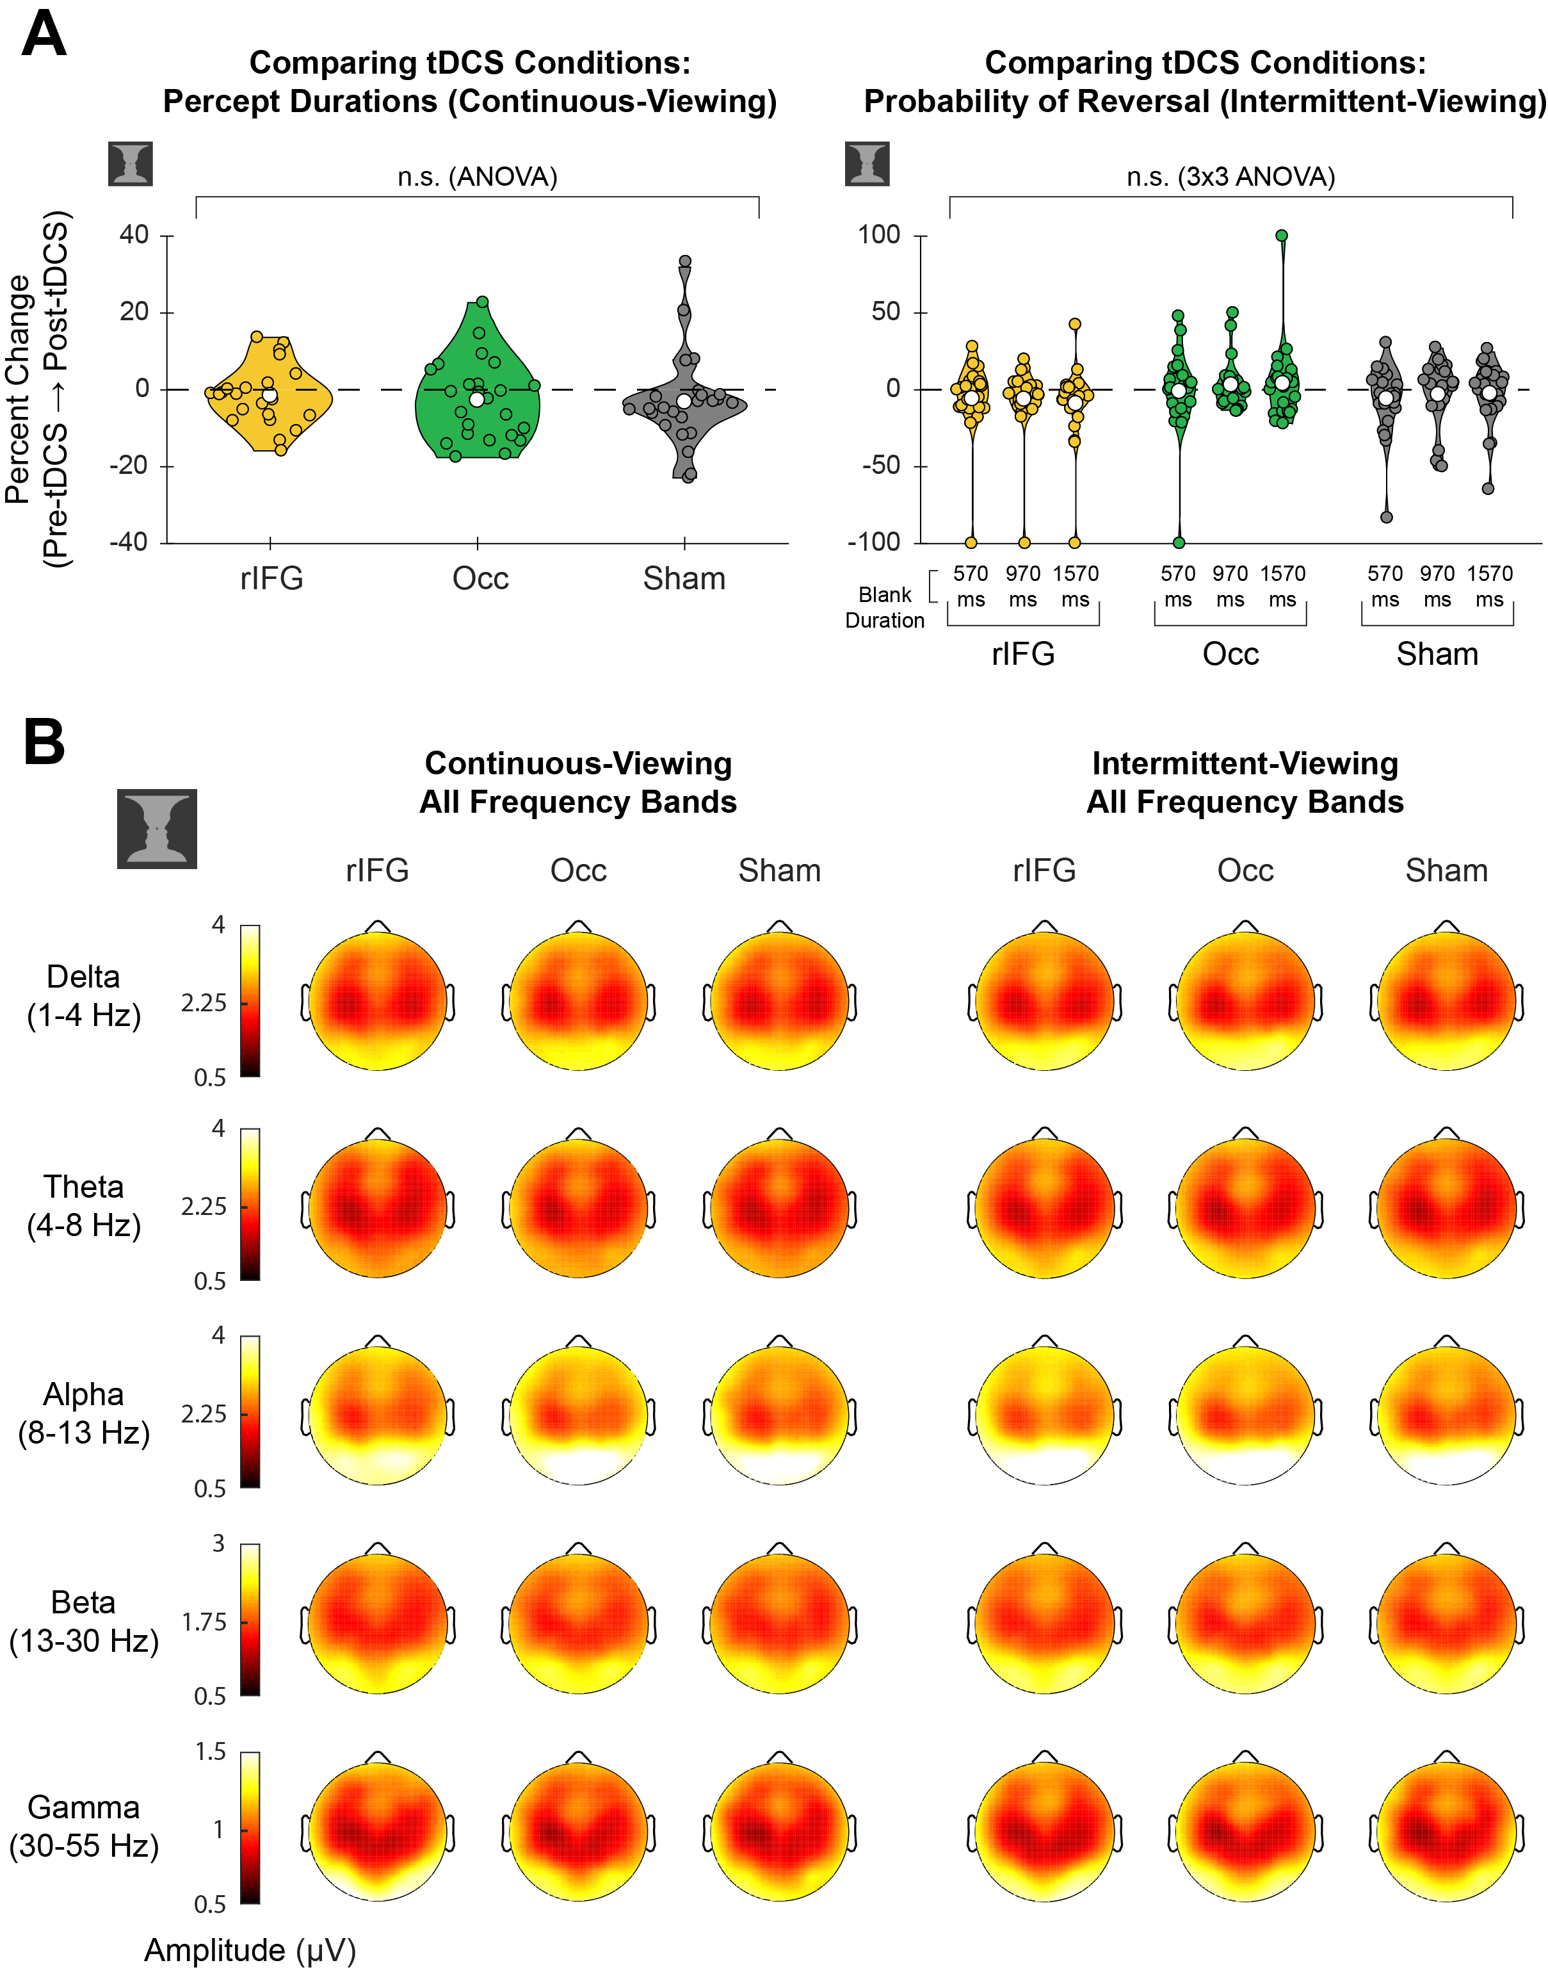
Fig. S2. Face-vase trials: comparing tDCS conditions. (A) Violin plots show %changes in behavioral measures from pre-tDCS task to post-tDCS task for face-vase trials. In the continuous-viewing condition (Left), percept durations did not differ significantly between tDCS conditions (repeated-measures ANOVA, F_{2, 44} = 1.062, p = 0.354). In the intermittent-viewing condition (Right), probability of reversal did not differ significantly between conditions (3x3 repeated-measures ANOVA, F_{2, 42} = 0.776, p = 0.467). (B) Topo-plots show mean amplitudes for each frequency band (Rows) during continuous-viewing (Left, N = 23) and in the 570-ms-blank trials of the intermittent-viewing condition (Right, N = 22) averaged across all subjects for face-vase trials. Amplitudes in each frequency band did not differ significantly between tDCS conditions (paired t-test, all p > 0.023, uncorrected across EEG channels).
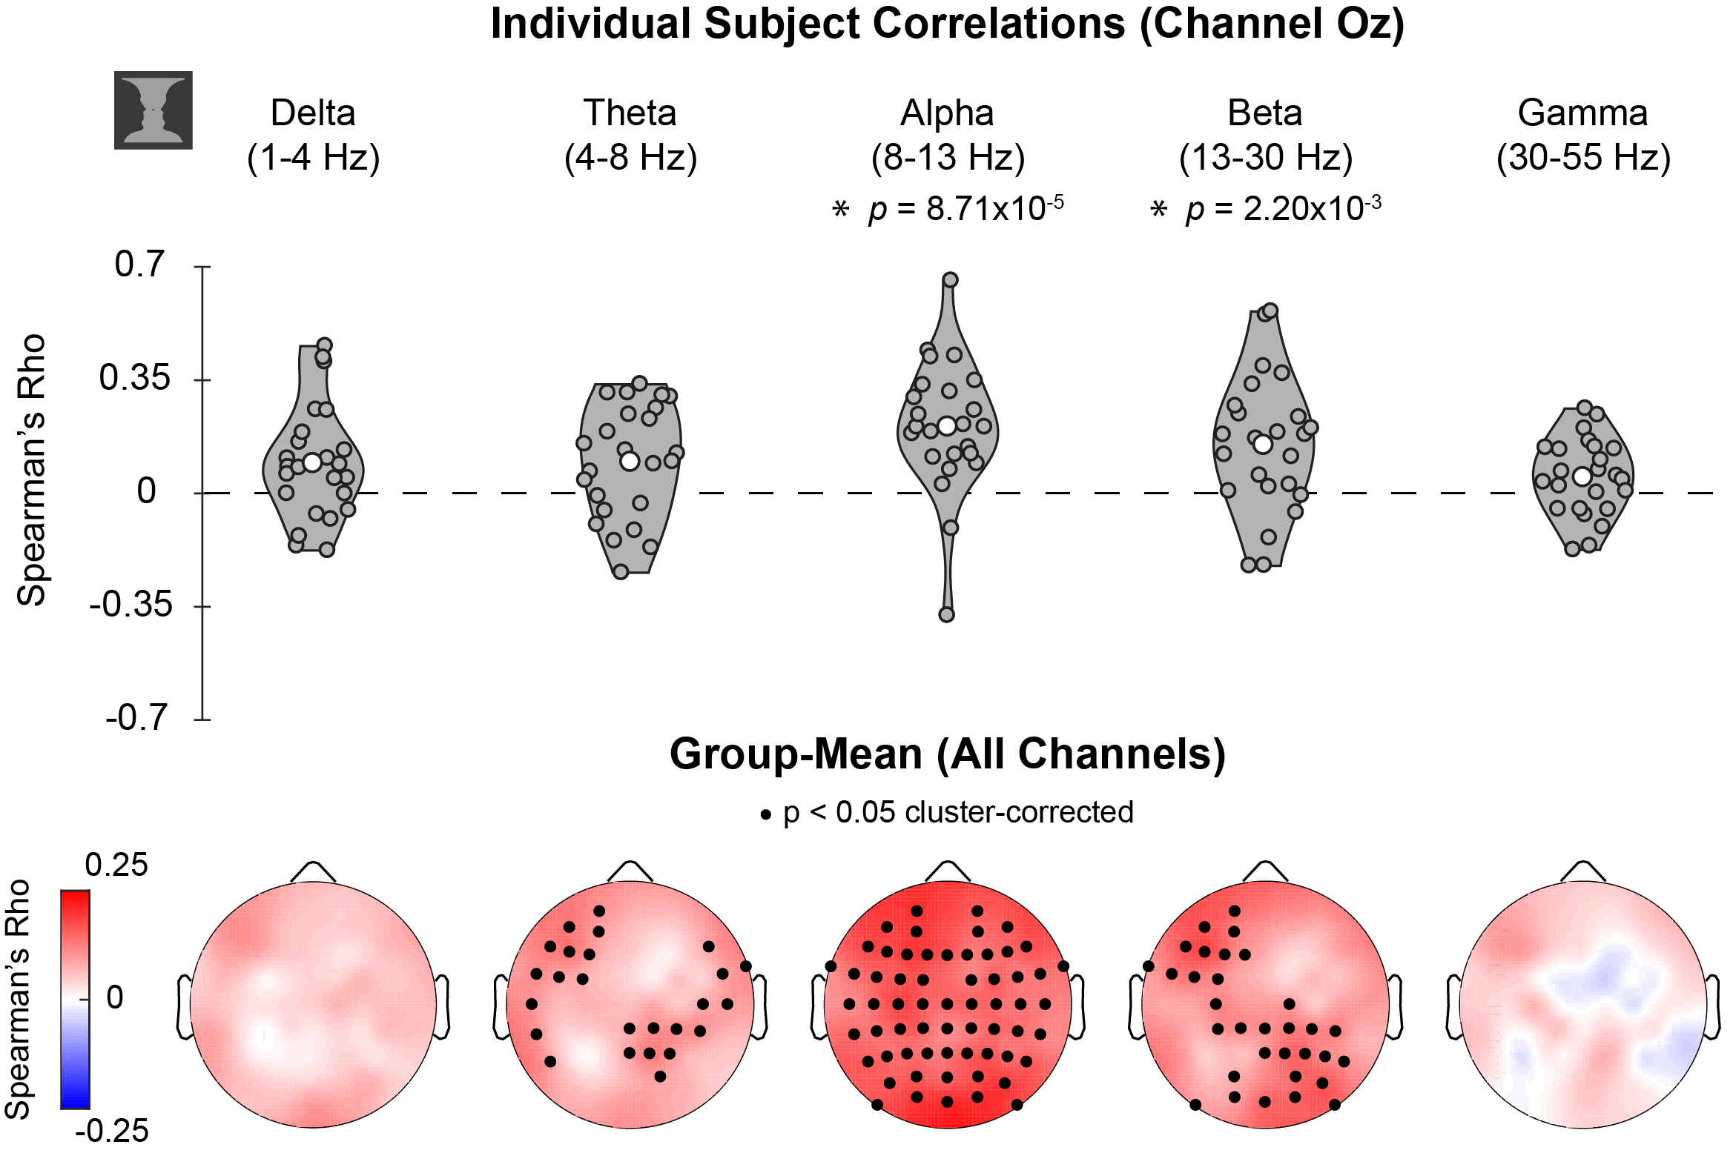
Fig. S3. Face-vase trials: correlating percept durations and band-limited amplitudes. Same as Fig. 3C but for face-vase trials.
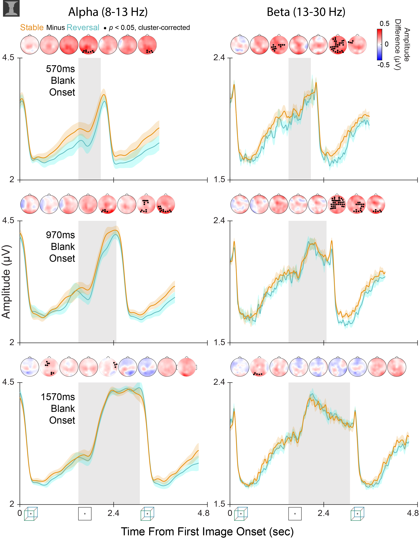
Fig. S4. Face-vase trials: time courses for alpha and beta amplitudes in intermittent-viewing condition. Same as Fig. 4B but for face-vase trials.
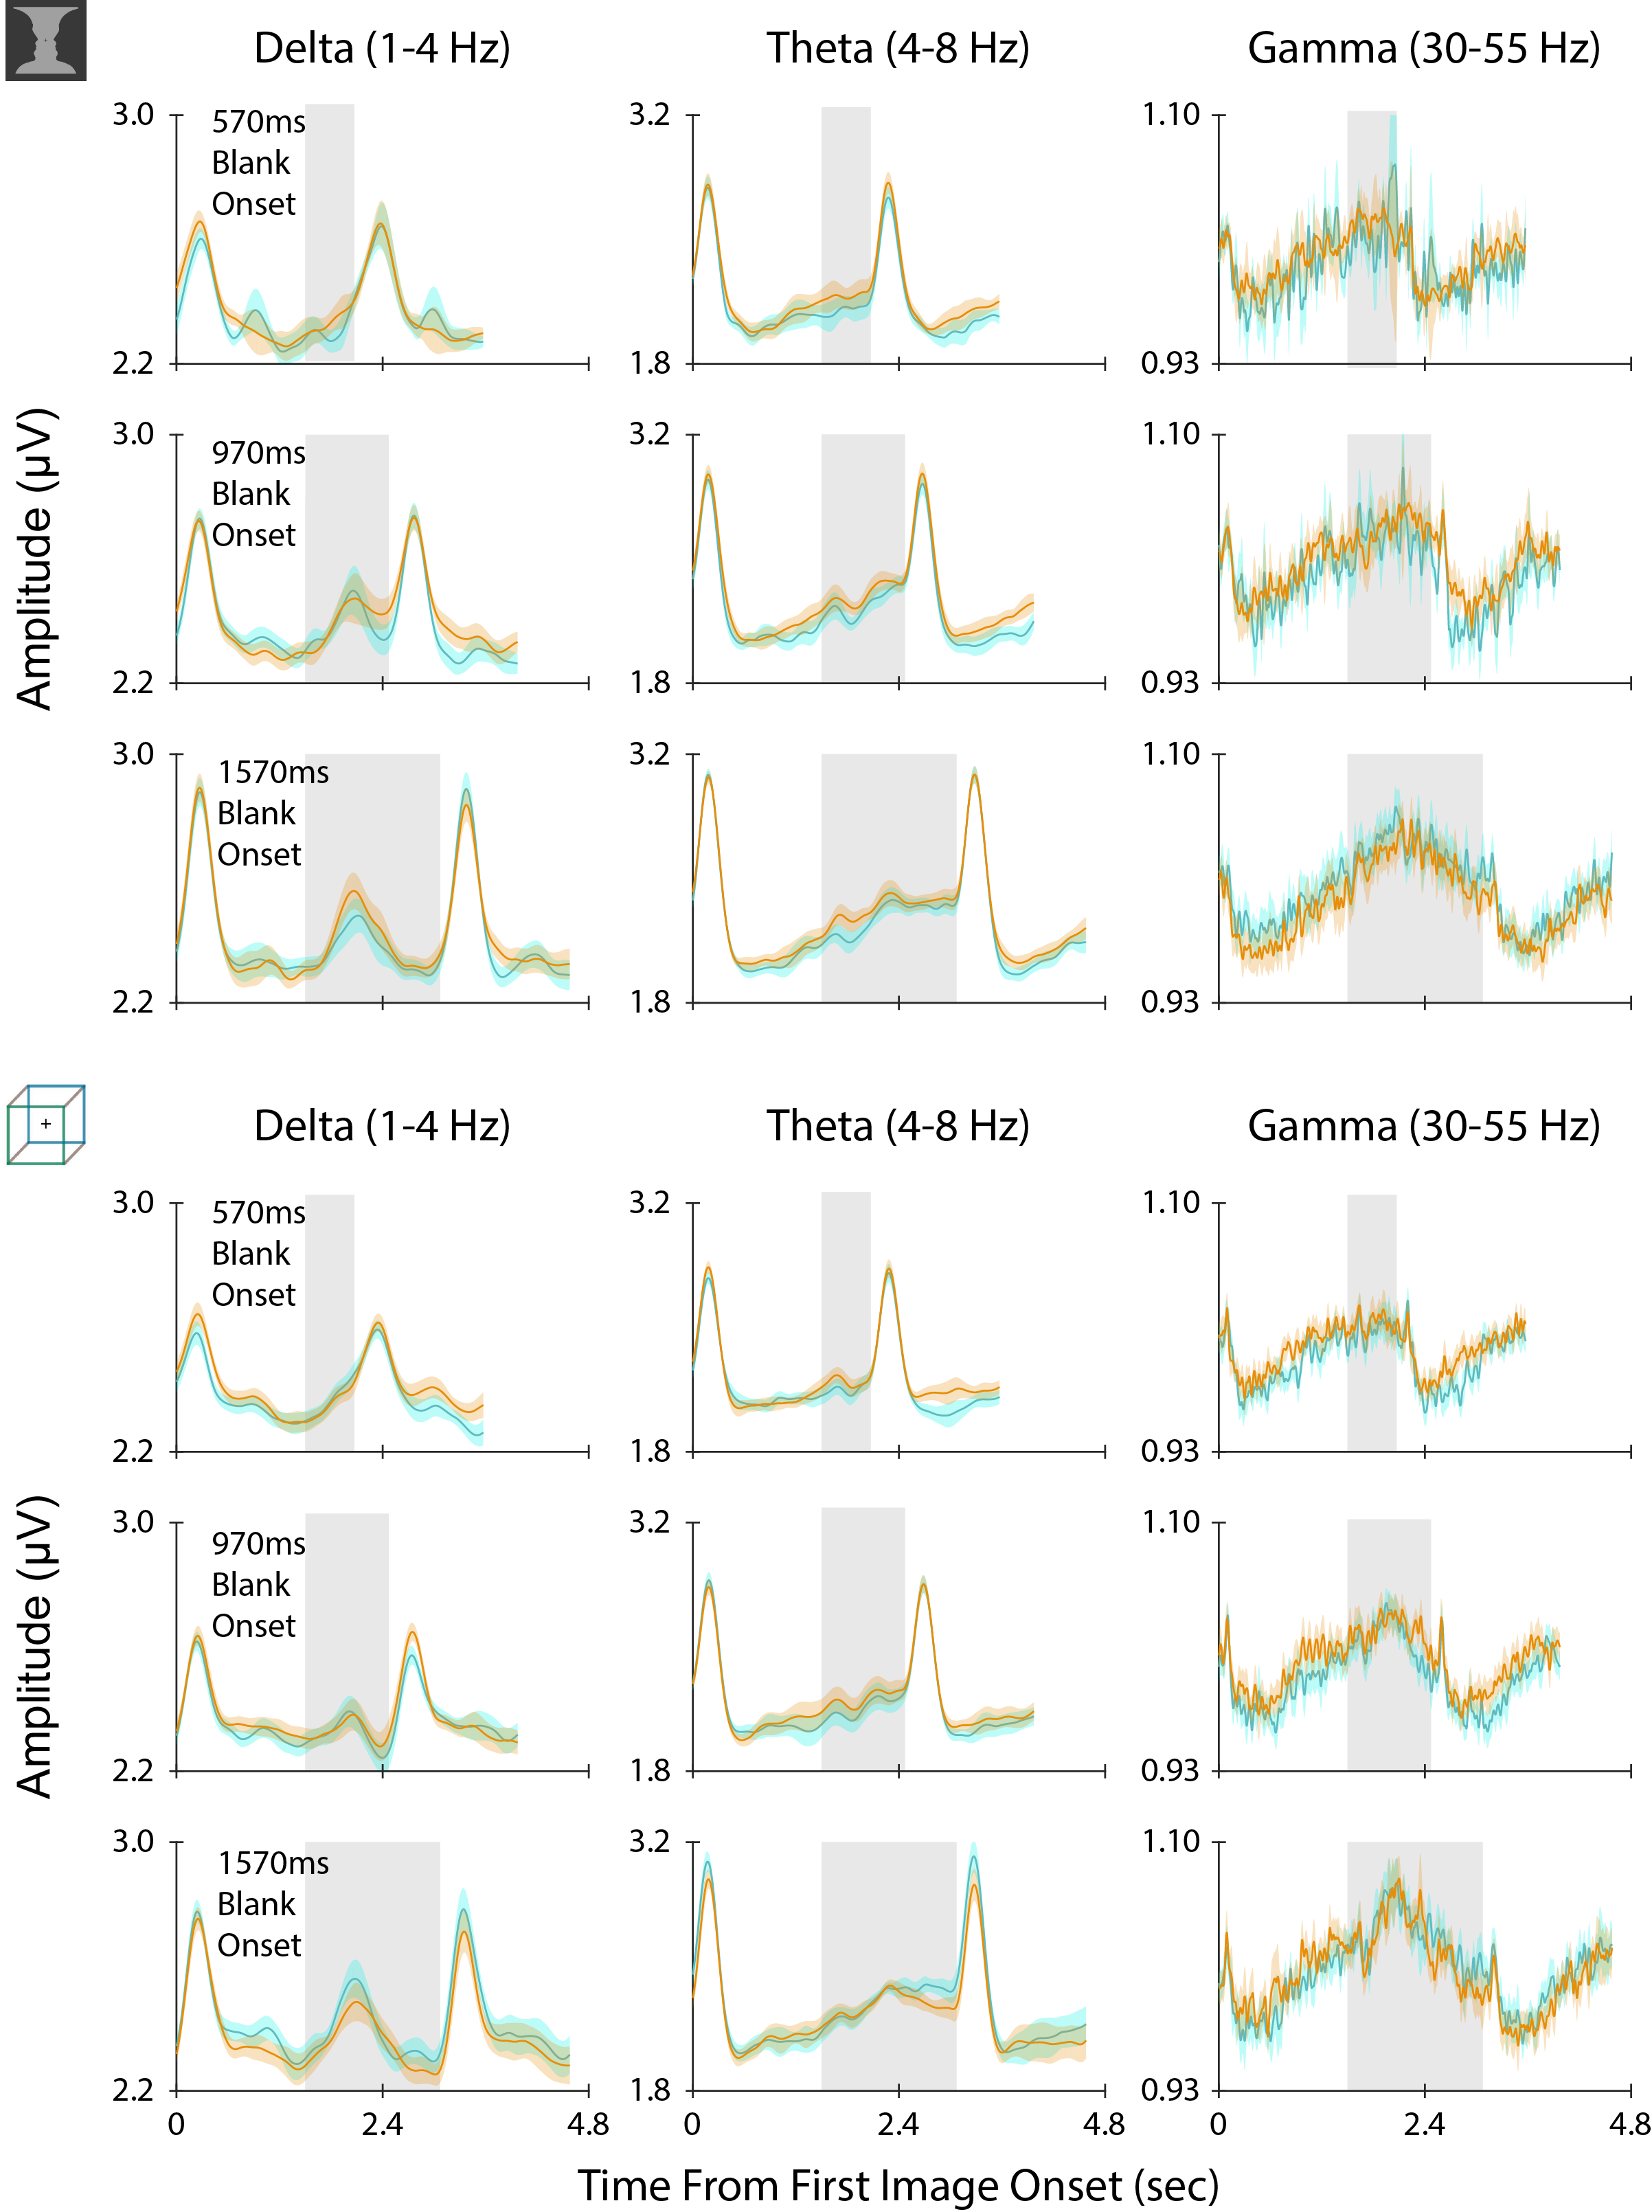Fig. S5. Time courses of amplitudes in all frequency bands in intermittent-viewing condition. Same as curves in Fig. 4B and Fig. S4 but for additional frequency bands.
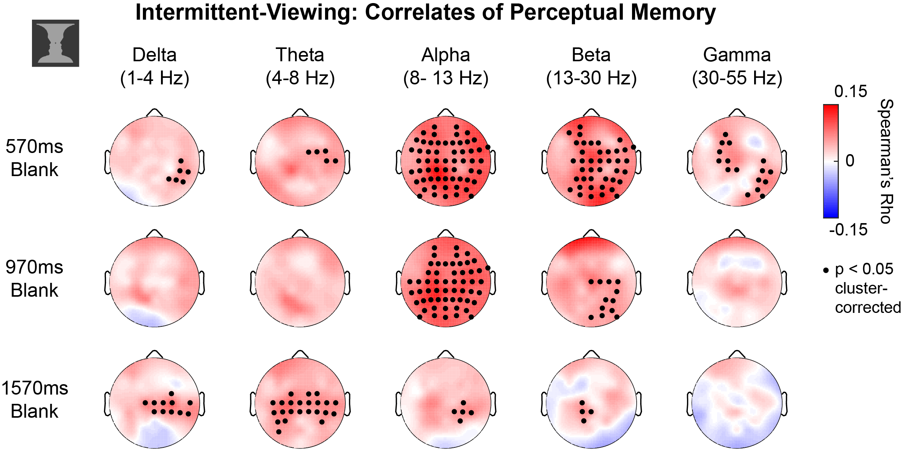
Fig. S6. Face-vase trials: correlating persistence of perceptual memory and band-limited amplitudes. Same as Fig. 5C but for face-vase trials.

